

The UK based founding organization, worldwide federation
and international consultancy for Rebound Therapy

Tel: 0330 122 5684 E-mail: info@ReboundTherapy.org Web: www.ReboundTherapy.org

Rebound Plus

TWO-DAY CERTIFICATED COURSE

The "Rebound Plus" course is a two-day add-on module for those who have already completed a genuine Rebound Therapy staff training course.
It is designed to equip candidates to help their more able students progress beyond Rebound Therapy and start the transition into mainstream trampolining exercises.
Dates and times: Thursday 3rd and Friday 4th July 2025
9:00am to 3:30pm on both days.

Venue: ISP School, Castlewood Farm, Conyer Road, Teynham, Kent, ME9 9EA.

Cost: £354 (plus VAT) per person = £424.80

Payment options: Cheque, Online or BACS see details below

This course also qualifies as step 2 of 3 in the Authority Sports UK Trampoline coach pathway

Please note the following: This course is not suitable for those who are pregnant. This course is not intended for recapping of skills previously learned. If you need to recap on anything from your previous Rebound Therapy course you should attend a one-day Rebound Therapy refresher workshop before booking onto this course.

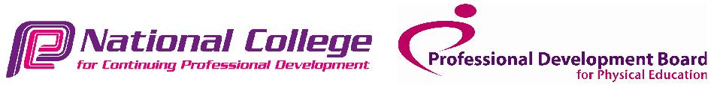

-----------------------------------------------------------------------------------------------------------------------------------------------------------------
Application Form for open “Rebound Plus” Training Course – 3rd and 4th July 2025

Name:………………………………………………………………DOB:………………………..……….

Address:…………………………………………………………………………………..………………...

Phone:……………………………….……………Email:……………….…………………………………

Occupation...…………………………………………………………………………………

Organisation represented:……………………………………………………………………

No. of places required:…............. Payment made by: Cheque........BACS........Online........Invoice reqd...........

Please return completed application form, and a copy of your Rebound Therapy course certificate to:

ReboundTherapy.org, Saplings, Felcourt Road, Felcourt, West Sussex, RH19 2LA

Reservations can only be accepted once full fee has been received.
- If paying by cheque, please make it payable to Rebound Therapy International Ltd.
- If paying online, please Click here or paste the following address into your browser:
https://www.reboundtherapy.org/courses/online_app
- Or BACS payments to: Nat West Bank 60-07-17 42774802.

VAT registration number 289285641
Rebound Therapy International Ltd registered in England at the address shown. Registration number 11224372

