The official UK body and international consultancy for Rebound Therapy
Endorsed and approved by the founder of RT; Eddy Anderson.

Tel: 0330 122 5684 E-mail: info@ReboundTherapy.org Web: www.ReboundTherapy.org

Saplings, Felcourt Road, Felcourt, W.Sussex, RH19 2LA

TWO-DAY CERTIFICATED COURSE IN REBOUND THERAPY

Alternative approaches to movement for people with Special Needs

Dates and times: Monday 13th and Tuesday 14th June 2022 9.00am to 3.30pm both days.

Venue: Longcause Community Special School, Longcause, Plympton, Plymouth, Devon, PL7 1JB.

Cost: £258 (plus VAT) per person

Payment options: Cheque, Online or BACS see details below

Course Outline: Safety Aspects; Appraisal of personal skills; Development and award programmes; Programmes for defined special needs; Problem solving – practical simulations
Candidates will each receive a copy of the ‘HFI for Winstrada’ manual for measuring outcomes.

This is a wide-ranging course, encompassing a variety of professional disciplines. We welcome those involved in various caring professions – specifically: Teachers, Teaching assistants, Physiotherapists, Occupational Therapists, Speech and Language Therapists, Nurses, Parents, Carers and Health workers. Also Trampoline Coaches.

For more information, contact ReboundTherapy.org using the contact details at the top of this page.
- - - - - - - - - - - - - - - - - - - - - - - - - - - - - - - - - - - - - - - - - - - - - - - - - - - - - - - - - - - - - - - - -

APPLICATION FORM

REBOUND THERAPY COURSE 13th and 14th June 2022,
Longcause Community Special School, Plymouth
Fee: £258 plus VAT = £309.60

Name:………………………………………………………………DOB:………………….

Address:……………………………………………………………………………………...

Phone:………………………………………Email:…………………………………………

Occupation...…………………………………………………………………………………

Organisation represented:……………………………………………………………………

No. of places required:…............. Payment made by: Cheque........BACS........Online........Invoice reqd...........

Please return completed application form to ReboundTherapy.org at: Rebound Therapy International Ltd, Saplings, Felcourt Road, Felcourt, West Sussex, RH19 2LA.
Reservations can only be accepted once full fee has been received.
- If paying by cheque, please make it payable to Rebound Therapy International Ltd.
- If paying online, please Click here or paste the following address into your browser:
https://www.reboundtherapy.org/courses/online_app
- Or BACS payments to: Nat West Bank 60-07-17 42774802.

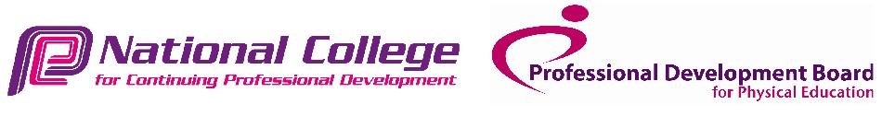VAT registration number 289285641
Rebound Therapy International Ltd registered in England. No. 11224372

